**LW_06 - CT/2021/009 – Premarathna A.H.N.P**

**Q1.**

Code:

***package Q_01;  
  
public class Main {  
 public static void main(String[] args) {  
 Dog obj1 = new Dog();  
 obj1.setName("Tommy");  
  
 System.out.println(obj1.speak());  
 System.out.println(obj1.getName());  
  
 Cat obj2 = new Cat();  
 obj2.setName("Kitty");  
 System.out.println(obj2.speak());  
 System.out.println(obj2.getName());  
 }  
}***

***package Q_01;  
  
public class Dog extends Pet {  
  
 public String speak() {  
  
 return " ";  
 }  
}***

***package Q_01;  
  
public class Cat extends Pet {  
  
 public String speak() {  
  
 return " ";  
 }  
}***

***package Q_01;  
  
public class Pet {  
 private String name;  
 public String getName( ) {  
 return name;  
 }  
 public void setName(String petName) {  
 name = petName;  
 }  
 public String speak( ) {  
 return "I'm your cuddly little pet.";  
 }  
}***

Output:

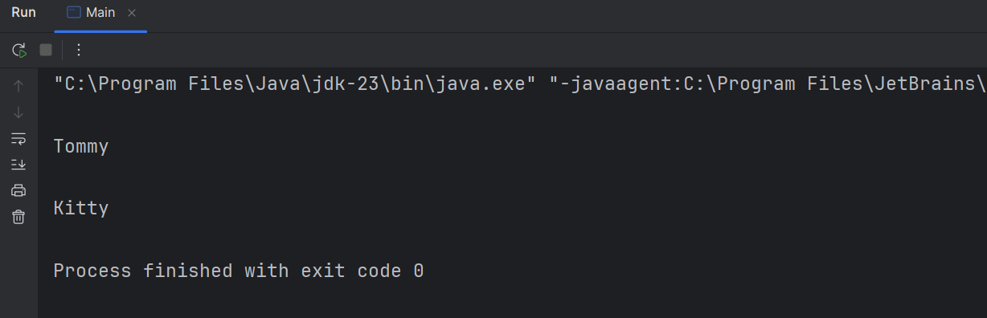

**Q2.**

Code:

***package Q_02;  
  
class Cat extends Pet {  
 public Cat(String name) {  
 super(name);  
 }  
  
   
 public String getType() {  
 return "Cat";  
 }  
}***

***package Q_02;  
  
class Pet {  
 protected String name;  
  
 public Pet(String name) {  
 this.name = name;  
 }  
  
 public String getType() {  
 return "Unknown";  
 }  
  
 public String getName() {  
 return name;  
 }  
}***

***package Q_02;  
  
import java.util.ArrayList;  
import java.util.List;  
import java.util.Scanner;  
  
public class Main {  
 public static void main(String[] args) {  
 Scanner scanner = new Scanner(System.in);  
 List <Pet> pets = new ArrayList<>();  
  
 while (true) {  
 System.out.print("Enter your pet's name (type 'STOP' to finish): ");  
 String name = scanner.nextLine();  
  
 if (name.equalsIgnoreCase("STOP")) {  
 break;  
 }  
  
 System.out.print("Enter your pet's type (c for Cat, d for Dog): ");  
 char type = scanner.next().charAt(0);  
 scanner.nextLine();  
  
 if (type == 'c' || type == 'C') {  
 pets.add(new Cat(name));  
 } else if (type == 'd' || type == 'D') {  
 pets.add(new Dog(name));  
 } else {  
 pets.add(new Pet(name)); // Unknown type  
 }  
 }  
  
 System.out.println("\n| Pet List |");  
 for (Pet pet : pets) {  
 System.out.println("Name: " + pet.getName() + " -> Type: " + pet.getType());  
 }  
 }  
}***

***package Q_02;  
  
class Dog extends Pet {  
 public Dog(String name) {  
 super(name);  
 }  
  
   
 public String getType() {  
 return "Dog";  
 }  
}***

Output:

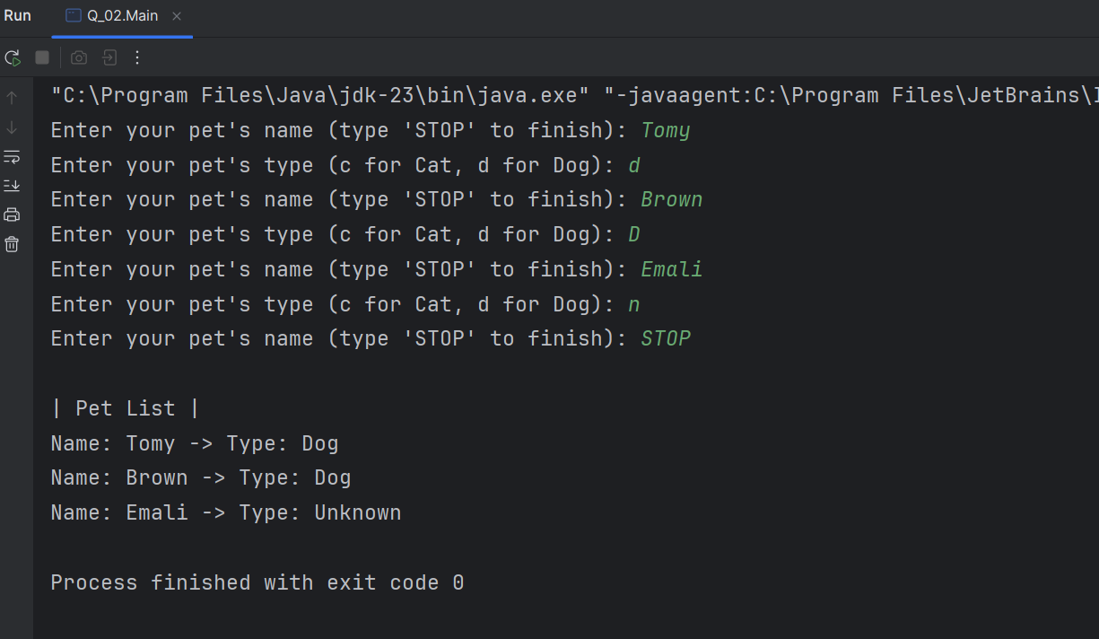

**Q3.**

Code:

***package Q_03;  
  
class Cat extends Pet {  
 public Cat(String name) {  
 super(name);  
 }  
  
   
 public String getType() {  
 return "Cat";  
 }  
}***

***package Q_03;  
  
class Dog extends Pet {  
 public Dog(String name) {  
 super(name);  
 }  
  
   
 public String getType() {  
 return "Dog";  
 }  
}***

***package Q_03;  
  
class Pet {  
 protected String name;  
  
 public Pet(String name) {  
 this.name = name;  
 }  
  
 public String getType() {  
 return "Unknown";  
 }  
  
 public String getName() {  
 return name;  
 }  
}***

***package Q_03;  
  
import java.util.ArrayList;  
import java.util.List;  
import java.util.Scanner;  
  
public class Main {  
 public static void main(String[] args) {  
 Scanner scanner = new Scanner(System.in);  
 List <Pet> pets = new ArrayList<>();  
  
 while (true) {  
 System.out.print("Enter your pet's name (type 'STOP' to finish): ");  
 String name = scanner.nextLine();  
  
 if (name.equalsIgnoreCase("STOP")) {  
 break;  
 }  
  
 System.out.print("Enter your pet's type (c for Cat, d for Dog): ");  
 char type = scanner.next().charAt(0);  
 scanner.nextLine();  
  
 if (type == 'c' || type == 'C') {  
 pets.add(new Cat(name));  
 } else if (type == 'd' || type == 'D') {  
 pets.add(new Dog(name));  
 } else {  
 pets.add(new Pet(name));  
 }  
 }  
  
 System.out.println("\n| Cat List |");  
 for (Pet pet : pets) {  
 if (pet instanceof Cat) {  
 System.out.println("Name: " + pet.getName());  
 }  
 }  
  
 System.out.println("\n| Dog List |");  
 for (Pet pet : pets) {  
 if (pet instanceof Dog) {  
 System.out.println("Name: " + pet.getName());  
 }  
 }  
  
 System.out.println("\n| Unknown Type List |");  
 for (Pet pet : pets) {  
 if (!(pet instanceof Cat) && !(pet instanceof Dog)) {  
 System.out.println("Name: " + pet.getName());  
 }  
 }  
  
 }  
  
}***

Output:

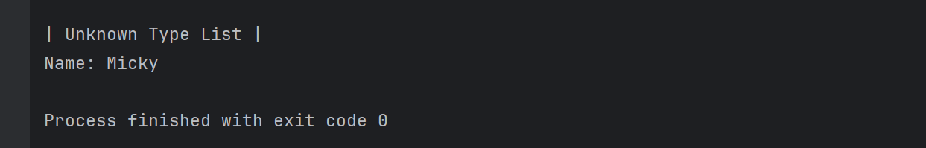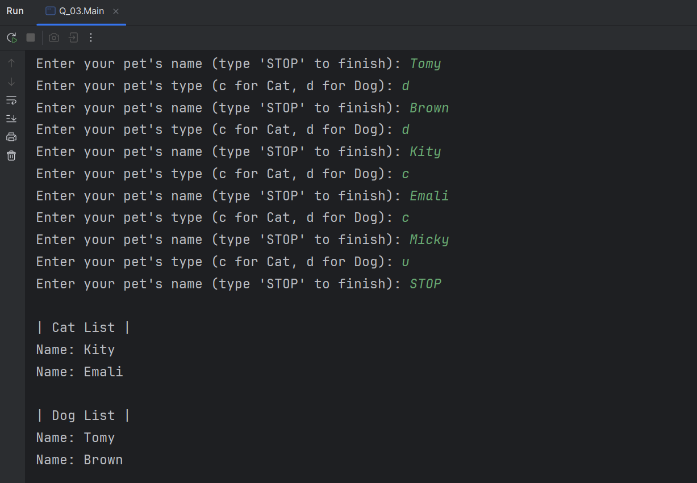

**Q4.**

Code:

***package Q_04;  
  
class Pet {  
 protected String name;  
  
 public Pet(String name) {  
 this.name = name;  
 }  
  
 public String getType() {  
 return "Unknown";  
 }  
  
 public String getName() {  
 return name;  
 }  
}***

***package Q_04;  
  
class Cat extends Pet {  
 private String coatColor;  
  
 public Cat(String name, String coatColor) {  
 super(name);  
 this.coatColor = coatColor;  
 }  
  
   
 public String getType() {  
 return "Cat";  
 }  
  
 public String getCoatColor() {  
 return coatColor;  
 }  
  
 public void setCoatColor(String coatColor) {  
 this.coatColor = coatColor;  
 }  
}***

***package Q_04;  
  
class Dog extends Pet {  
 private double weight;  
  
 public Dog(String name, double weight) {  
 super(name);  
 this.weight = weight;  
 }  
  
 public String getType() {  
 return "Dog";  
 }  
  
 public double getWeight() {  
 return weight;  
 }  
  
 public void setWeight(double weight) {  
 this.weight = weight;  
 }  
}***

***package Q_04;  
  
import java.util.ArrayList;  
import java.util.List;  
import java.util.Scanner;  
  
public class Main {  
 public static void main(String[] args) {  
 Scanner scanner = new Scanner(System.in);  
 List <Pet> pets = new ArrayList<>();  
  
 while (true) {  
 System.out.print("Enter your pet's name (type 'STOP' to finish): ");  
 String name = scanner.nextLine();  
  
 if (name.equalsIgnoreCase("STOP")) {  
 break;  
 }  
  
 System.out.print("Enter your pet's type (c for Cat, d for Dog): ");  
 char type = scanner.next().charAt(0);  
 scanner.nextLine();  
  
 if (type == 'c' || type == 'C') {  
 System.out.print("Enter your cat's coat color: ");  
 String coatColor = scanner.nextLine();  
 pets.add(new Cat(name, coatColor));  
 } else if (type == 'd' || type == 'D') {  
 System.out.print("Enter your dog's weight (in kg): ");  
 double weight = scanner.nextDouble();  
 scanner.nextLine();  
 pets.add(new Dog(name, weight));  
 } else {  
 pets.add(new Pet(name)); // Unknown  
 }  
  
 }  
  
 System.out.println("\n| Cat List |");  
 for (Pet pet : pets) {  
 if (pet instanceof Cat) {  
 Cat cat = (Cat) pet;  
 System.out.println("Name: " + cat.getName() + " -> Type: Cat -> Coat Color: " + cat.getCoatColor());  
 }  
 }  
  
 System.out.println("\n| Dog List |");  
 for (Pet pet : pets) {  
 if (pet instanceof Dog) {  
 Dog dog = (Dog) pet;  
 System.out.println("Name: " + dog.getName() + " -> Type: Dog -> Weight: " + dog.getWeight() + " kg");  
 }  
 }  
  
  
 }  
  
}***

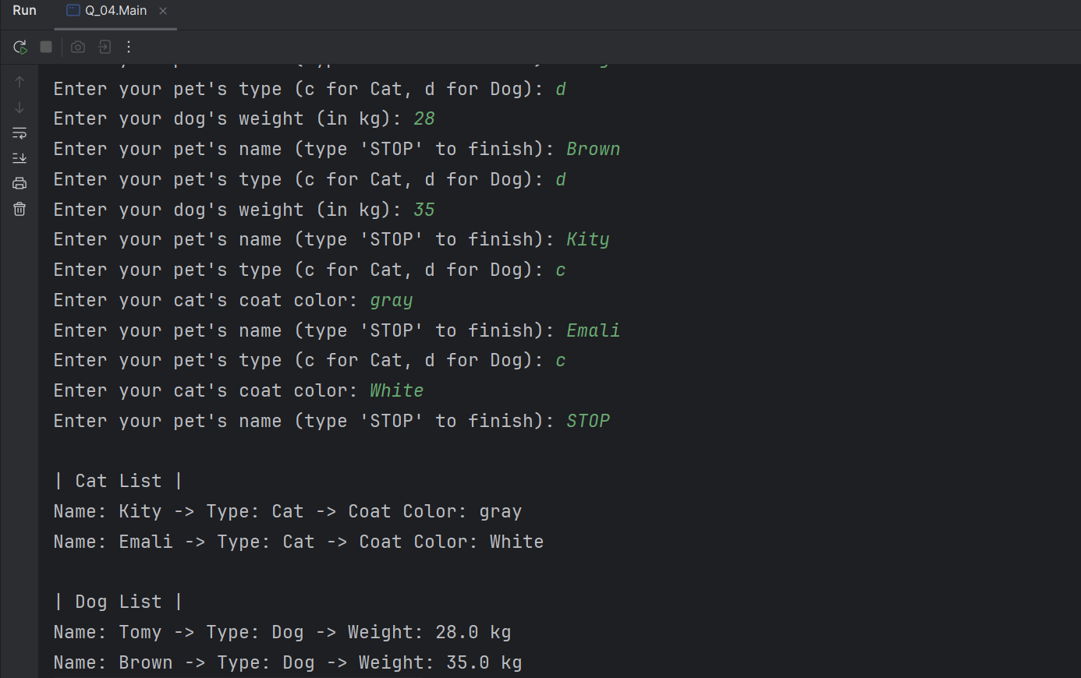Output:

**Q5.**

Code:

***package Q_05;  
  
class Dog extends Pet {  
 private double weight;  
  
 public Dog(String name, double weight) {  
 super(name);  
 this.weight = weight;  
 }  
  
 public String getType() {  
 return "Dog";  
 }  
  
 public double getWeight() {  
 return weight;  
 }  
  
 public void setWeight(double weight) {  
 this.weight = weight;  
 }  
}***

***package Q_05;  
  
class Pet {  
 protected String name;  
  
 public Pet(String name) {  
 this.name = name;  
 }  
  
 public String getType() {  
 return "Unknown";  
 }  
  
 public String getName() {  
 return name;  
 }  
}***

***package Q_05;  
  
import java.util.ArrayList;  
import java.util.List;  
import java.util.Scanner;  
  
public class Main {  
 public static void main(String[] args) {  
 Scanner scanner = new Scanner(System.in);  
 List <Pet> pets = new ArrayList<>();  
  
 while (true) {  
 System.out.print("Enter your pet's name (type 'STOP' to finish): ");  
 String name = scanner.nextLine();  
  
 if (name.equalsIgnoreCase("STOP")) {  
 break;  
 }  
  
 System.out.print("Enter your pet's type (c for Cat, d for Dog): ");  
 char type = scanner.next().charAt(0);  
 scanner.nextLine();  
  
 if (type == 'c' || type == 'C') {  
 System.out.print("Enter your cat's coat color: ");  
 String coatColor = scanner.nextLine();  
 pets.add(new Cat(name, coatColor));  
 } else if (type == 'd' || type == 'D') {  
 System.out.print("Enter your dog's weight (in kg): ");  
 double weight = scanner.nextDouble();  
 scanner.nextLine();  
 pets.add(new Dog(name, weight));  
 } else {  
 pets.add(new Pet(name)); // Unknown  
 }  
  
 }  
 List<Dog> dogList = new ArrayList<>();***

***package Q_05;  
  
class Cat extends Pet {  
 private String coatColor;  
  
 public Cat(String name, String coatColor) {  
 super(name);  
 this.coatColor = coatColor;  
 }  
  
 public String getType() {  
 return "Cat";  
 }  
  
 public String getCoatColor() {  
 return coatColor;  
 }  
  
 public void setCoatColor(String coatColor) {  
 this.coatColor = coatColor;  
 }  
}***

***for (Pet pet : pets) {  
 if (pet instanceof Dog) {  
 dogList.add((Dog) pet);  
 }  
 }  
  
 System.out.println("\n| Cat List |");  
 for (Pet pet : pets) {  
 if (pet instanceof Cat) {  
 Cat cat = (Cat) pet;  
 System.out.println("Name: " + cat.getName() + " -> Type: Cat -> Coat Color: " + cat.getCoatColor());  
 }  
 }  
  
 System.out.println("\n| Dog List |");  
 for (Pet pet : pets) {  
 if (pet instanceof Dog) {  
 Dog dog = (Dog) pet;  
 System.out.println("Name: " + dog.getName() + " -> Type: Dog -> Weight: " + dog.getWeight() + " kg");  
 }  
 }  
 if (!dogList.isEmpty()) {  
 double totalWeight = 0;  
 double minWeight = dogList.get(0).getWeight();  
 double maxWeight = dogList.get(0).getWeight();  
  
 for (Dog dog : dogList) {  
 double weight = dog.getWeight();  
 totalWeight += weight;  
  
 if (weight < minWeight) {  
 minWeight = weight;  
 }  
  
 if (weight > maxWeight) {  
 maxWeight = weight;  
 }  
 }  
  
 double averageWeight = totalWeight / dogList.size();  
  
 System.out.println("\n| Dog Weight Stats |");  
 System.out.println("Average Weight: " + averageWeight + " kg.");  
 System.out.println("Minimum Weight: " + minWeight + " kg.");  
 System.out.println("Maximum Weight: " + maxWeight + " kg.");  
 } else {  
 System.out.println("\nNo dogs were entered to calculate weight statistics.");  
 }  
  
  
  
 }  
  
}***

Output:

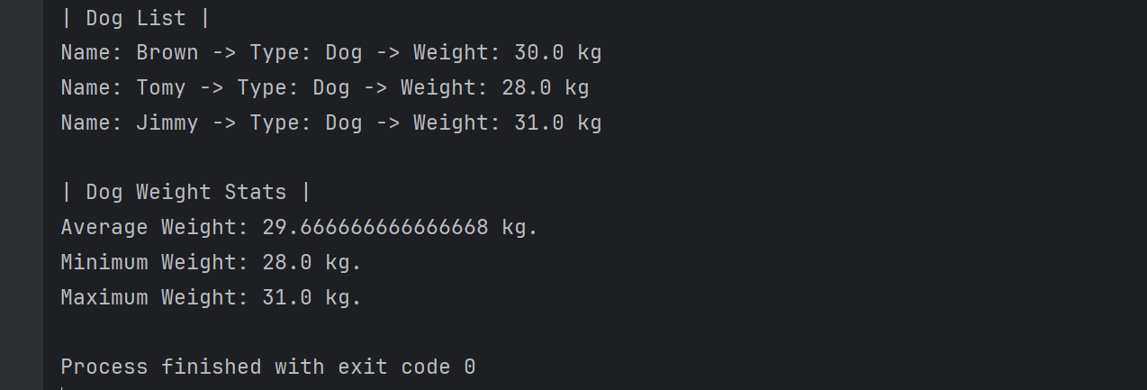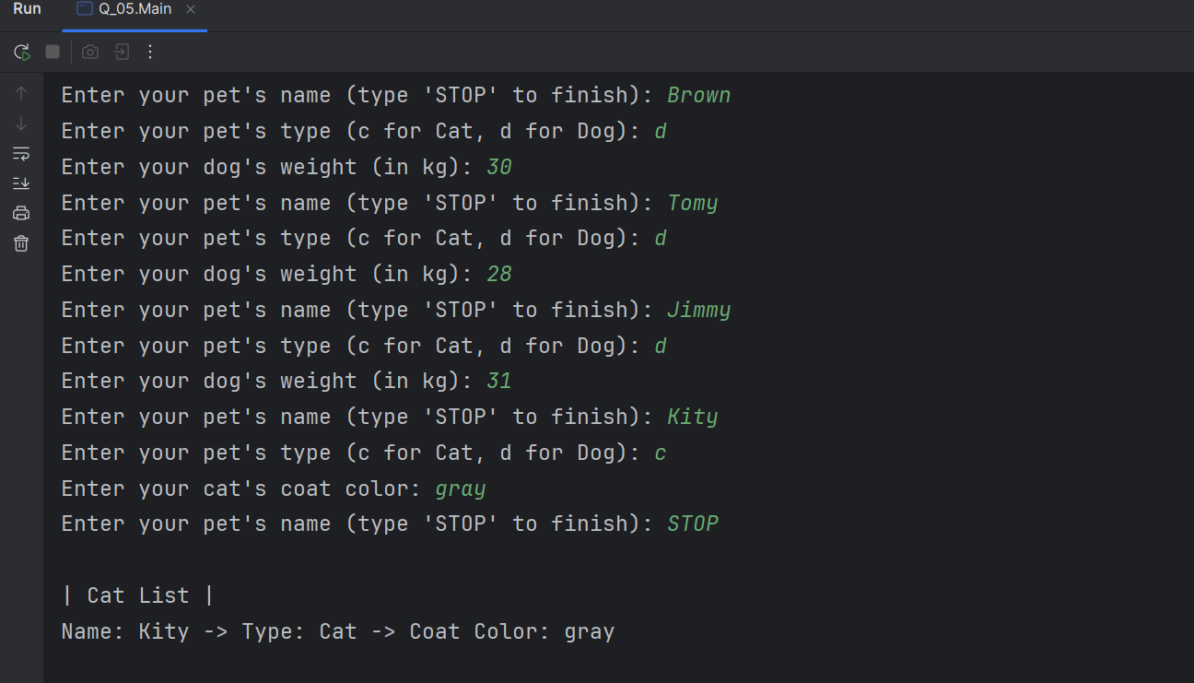

**Q6.**

***package Q_06;  
  
class Cat extends Pet {  
 private String coatColor;  
  
 public Cat(String name, String coatColor) {  
 super(name);  
 this.coatColor = coatColor;  
 }  
  
 public String getType() {  
 return "Cat";  
 }  
  
 public String getCoatColor() {  
 return coatColor;  
 }  
  
 public void setCoatColor(String coatColor) {  
 this.coatColor = coatColor;  
 }  
}***

***package Q_06;  
  
class Pet {  
 protected String name;  
  
 public Pet(String name) {  
 this.name = name;  
 }  
  
 public String getType() {  
 return "Unknown";  
 }  
  
 public String getName() {  
 return name;  
 }  
}***

***package Q_06;  
  
class Dog extends Pet {  
 private double weight;  
  
 public Dog(String name, double weight) {  
 super(name);  
 this.weight = weight;  
 }  
  
 public String getType() {  
 return "Dog";  
 }  
  
 public double getWeight() {  
 return weight;  
 }  
  
 public void setWeight(double weight) {  
 this.weight = weight;  
 }  
}***

***package Q_06;  
  
import java.util.ArrayList;  
import java.util.List;  
import java.util.Scanner;  
  
public class Main {  
 public static void main(String[] args) {  
 Scanner scanner = new Scanner(System.in);  
 List<Pet> pets = new ArrayList<>();  
 List<Dog> dogList = new ArrayList<>();  
 List<Cat> catList = new ArrayList<>();  
  
 int choice;  
  
 do {  
 System.out.println("\n| Pet Menu |");  
 System.out.println("1. Add Cat");  
 System.out.println("2. Add Dog");  
 System.out.println("3. Remove Cat");  
 System.out.println("4. Remove Dog");  
 System.out.println("0. Quit");  
 System.out.print("Enter your choice: ");  
 choice = scanner.nextInt();  
 scanner.nextLine();  
  
 switch (choice) {  
 case 1: // Add Cat  
 System.out.print("Enter cat's name: ");  
 String catName = scanner.nextLine();  
 System.out.print("Enter cat's coat color: ");  
 String coatColor = scanner.nextLine();  
  
 Cat cat = new Cat(catName, coatColor);  
 pets.add(cat);  
 catList.add(cat);  
 System.out.println("Cat added.");  
 break;  
  
 case 2: // Add Dog  
 System.out.print("Enter dog's name: ");  
 String dogName = scanner.nextLine();  
 System.out.print("Enter dog's weight (in kg): ");  
 double weight = scanner.nextDouble();  
 scanner.nextLine();  
  
 Dog dog = new Dog(dogName, weight);  
 pets.add(dog);  
 dogList.add(dog);  
 System.out.println("Dog added.");  
 break;  
  
 case 3: // Remove Cat  
 System.out.print("Enter the name of the cat to remove: ");  
 String removeCatName = scanner.nextLine();  
  
 catList.removeIf(c -> c.getName().equalsIgnoreCase(removeCatName));  
 pets.removeIf(p -> p instanceof Cat && p.getName().equalsIgnoreCase(removeCatName));  
 System.out.println("Cat removed...");  
 break;***

***case 4: // Remove Dog  
 System.out.print("Enter the name of the dog to remove: ");  
 String removeDogName = scanner.nextLine();  
  
 dogList.removeIf(d -> d.getName().equalsIgnoreCase(removeDogName));  
 pets.removeIf(p -> p instanceof Dog && p.getName().equalsIgnoreCase(removeDogName));  
 System.out.println("Dog removed...");  
 break;  
  
 case 0:  
 System.out.println("Exiting program.");  
 break;  
  
 default:  
 System.out.println("Invalid choice. Please enter 0–4.");  
 }  
  
 } while (choice != 0);  
  
 // List of currently included dogs and cats  
 System.out.println("\n| Final Cat List |");  
 if (catList.isEmpty()) {  
 System.out.println("No cats in the list!");  
 } else {  
 for (Cat c : catList) {  
 System.out.println("Name: " + c.getName() + " -> Coat Color: " + c.getCoatColor());  
 }  
 }  
  
 System.out.println("\n| Final Dog List |");  
 if (dogList.isEmpty()) {  
 System.out.println("No dogs in the list!");  
 } else {  
 for (Dog d : dogList) {  
 System.out.println("Name: " + d.getName() + " -> Weight: " + d.getWeight() + " kg");  
 }  
 }  
  
  
 }  
}***

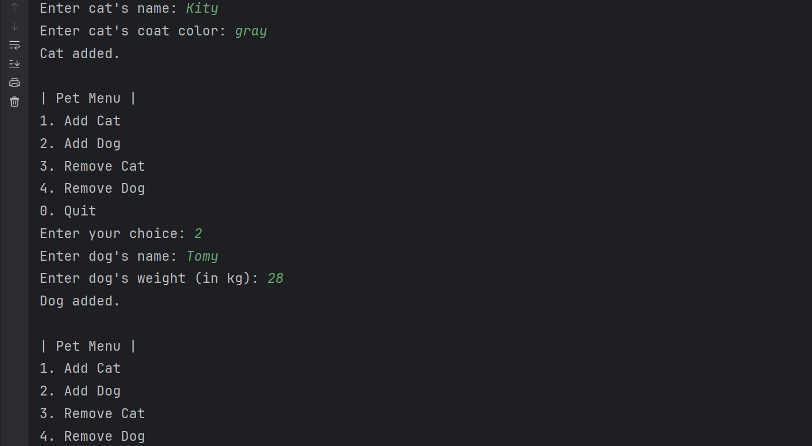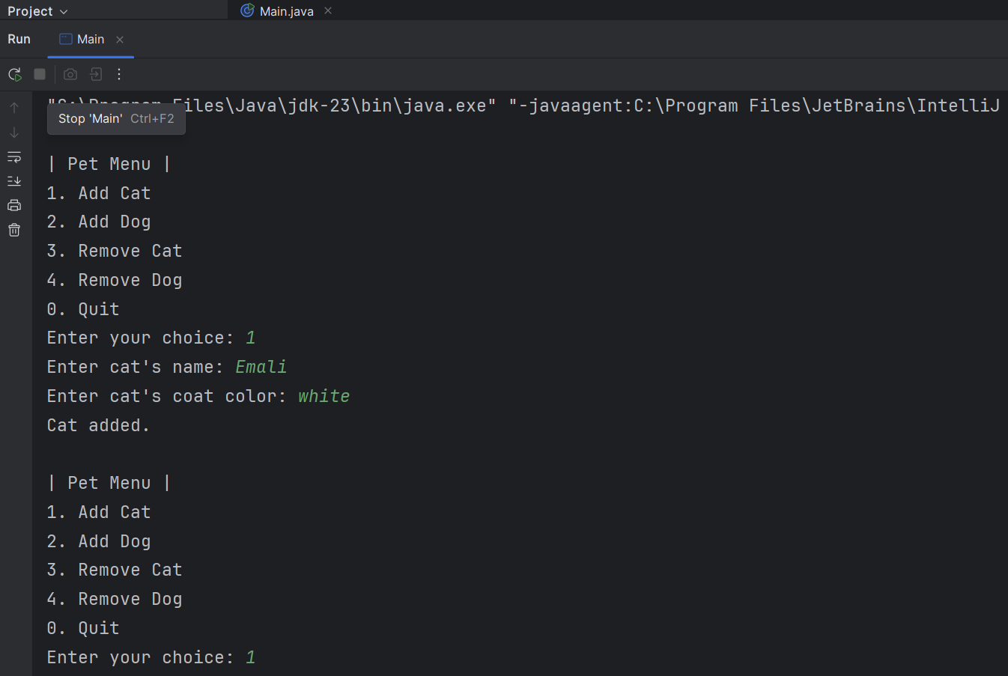Output:

